Table of Contents

**1. Introduction** 1

**1.1 Purpose of Plan Document** 1

**1.2 Project Scope and Objectives** 1

**1.2.1 Statement of Scope** 1

**1.2.2 Major Functions** 1

**1.3 Overview of Document** 2

**2. Project Organization** 2

**2.1 Team Structure** 2

**2.2 Development Methodology** 2

**2.3 Management Reporting** 3

**3. Project Resources** 3

**3.1 Personnel** 4

**3.2 Customer** 4

**3.3 Consultants** 4

**3.4 Hardware** 4

**3.5 Software** 4

**4. Risk Management** 4

**4.1 Likely Risks** 5

**4.2 Risks Management Plan** 5

**4.3 Risk Monitoring** 5

**4.4 Risk Managerial** 5

**5. Schedule** 6

**5.1 Task List and Resource Allocation** 6

**5.2 Time Line** 8

**5.3 Task Network Diagram** 8

**5.4 Object Grading Sheet** 9

**6. Tracking and Control Mechanisms** 9

**6.1 Quality Assurance and Quality Control** 9

**6.2 Change Management Control** 10

**7. References** 10

# **1. Introduction**

This section outlines the purpose of this document and the scope and objectives of the project.

## **1.1 Purpose of Plan Document**

The purpose of this document is to detail distinctive areas of the project for the effective development of software. It describes the way to deal with the stages of the software development process. It establishes the process model that will be used for the project. All the tasks involved during project development are ordered to complete the project in allotted time. The plan shows how the team is organized and the method of communication between the team members with respect to project deliverables. Risks involved while developing the application and how to overcome those are addressed. Also, this document specifies the method of reporting and quality assurance.

## **1.2 Project Scope and Objectives**

This section outlines the scope and major functions of the project.

## **1.2.1 Statement of Scope**

The user currently writes notes manually in a book. That book acts as “data storage”, which has to be carried everywhere. An application that stores all the data electronically is to be designed so that user can easily search the data. This project allows the user to write notes about events. It keeps a record of events in an e-format accessible on a tablet. It allows the user to search for an event of certain type, name or timespan and displays the results. The model will provide an easy to use, graphical UI that deals with the user operations to search or add a task.

### **1.2.2 Major Functions**

The application will have the ability to perform the following major functions.

1.2.2.1 Add Entry: This function will display the user interface that will allow for a new task to entered and added to the system.

1.2.2.2 Select/Add Task Type: This function will allow the user to select one of the existing tasks or be able to add a new task if needed to the collection of tasks.

1.2.2.3 Select/Add Person: This function will allow the user to select one or many of the existing persons or organizations or be able to add a new person or organization if needed to the collection of persons.

1.2.2.4 Enter Comment: This function will allow the user to enter input that will be assigned to the current task. This function will be designed to work with handwriting to text recognition software.

1.2.2.5 Update: This function will update the system with the newly input task specifications.

1.2.2.6 Search: This function will display the user interface that will allow for a task to be searched and displayed.

1.2.2.7 Select Filter Start Date: This function will allow the user to input a start date to filter their search.

1.2.2.8 Select Filter End Date: This function will allow the user to input an end date to filter their search.

1.2.2.9. Select Filter Task Type: This function will allow the user to select one of the existing tasks to filter their search.

1.2.2.10 Select Filter Person: This function will allow the user to select one or many of the existing persons to filter their search.

1.2.2.11 Select Filter Keywords: This function will allow the user to provide input that will be utilized to filter their search in the comment attribute. This function will be designed to work with handwriting to text recognition software.

1.2.2.12 Cancel: This function will allow the user to navigate to the Home Page.

## **1.3 Overview of Document**

The rest of this document is intended to provide information about project organization, project resources, risk management, schedule, and tracking and control mechanisms.

# **2. Project Organization**

Team TriNetra has accepted the contract to develop an electronic task logger on an Android tablet system for Dr. Catherine Stringfellow. Team members are committed to developing this application utilizing a modified version of the scrum agile process model. This process model will be followed and utilized for task scheduling of specific mile stones during the development cycle.

## **2.1 Team Structure**

During the developmental cycle of this project our team will utilize a democratic, decentralized model for the team structure. All tasks and appoints will be decided upon during regular meetings, which will have all members contributing something to each part of the development process. These parts include: requirements specification, project planning, project design, coding and implementation, and testing. Every member’s input will be valued and listened to and as a unit will decide the appropriate course of action for the current task.

## **2.2 Development Methodology**

Team TriNetra will be utilizing a modified version of the agile scrum process model. That is following the practices of backlog, sprints, scrum meetings, and demos. Our timing for the process will be slightly different than normal as our entire development process is only 15 weeks long. We will have a defined and prioritized backlog or schedule of tasks that are to be completed during each sprint. Sprints are planned to be one week in length, normally Friday to Friday. Instead of daily scrum meetings, we have opted to have meetings on the odd days of the work week, Monday, Wednesday, and Friday that should last 15 to 30 minutes, around 10:00. The scrum master is replaced with more of a democratic approach as the team consists of three members only. As one member is providing answers and updates during the scrum the other two will be listening and evaluating, both filling the role of the scrum master. There will be a scribe that will document what is discussed, appointed, and completed during each scrum as well. These documents will be used to create reports for the customer to show progress is being made during development. After each sprint the team will hopefully be able to be in contact with our customer so that demos or builds of the application can be demonstrated, and feedback acquired for the next sprint or implementation. Below, depicted in Figure 1., is a modified version of the scrum process model taken from Pressman[3].

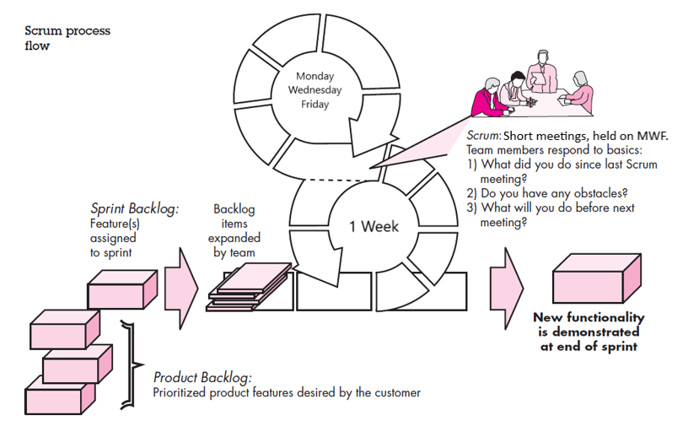

Figure 1. A modified depiction of the Scrum process model[3].

## **2.3 Management Reporting**

When the team was appointed, before any methodology had been set, we had brief meetings on Friday mornings where the team name, logo, and project were discussed and decided upon. The decision to have an incremental based methodology evolved to using Scrum practices to produce our project. All of the features that will be implemented are placed in a product backlog. The higher priority features will then be assigned to a sprint. If additional time is required to meet, such as during the design and implementation phases of development, Wednesday afternoons at 14:30 can be utilized as that time was decided upon by the team. There tasks can be decided upon and distributed for work to team members. The team is utilizing email for distance communication in-between scrum meetings, as well as, the text messaging application Whatsapp for more informal communication. The budget for this application is zero dollars, but it is of extreme value to our customer for functionality, while it has valuable educational purposes for team TriNetra.

# **3. Project Resources**

Team TriNetra has an assortment of resources available that will be utilized in the development of this project. These resources include: personnel, customer, consultants, hardware, and software.

## **3.1 Personnel**

Team TriNetra consists of the following members: Anusha Karnati, Sai Kishan Naraparaju, and Matthew Schenk. All of which are graduate students at Midwestern State University, who have committed to working on this project until its delivery date. As we work together, we are striving to learn and teach one another throughout this software development process, while also combining our own knowledge, experiences, and expertise to develop this application in the best way possible.

## **3.2 Customer**

Dr. Catherine Stringfellow is the customer and primary user for our application. She provides an invaluable source of knowledge and feedback on how she would like this application to work. She has specified the requirements which has allowed Team TriNetra to create a detailed user context found in our requirements document. This information will be referred to by the team throughout the software development process.

## **3.3 Consultants**

Dr. Terry Griffin has instructed numerous courses at Midwestern State University involving mobile application development. He was able to provide insight and guidance on which software systems, languages, and frameworks are the most valuable. He also informed us on which of the previous items he thinks would be most beneficial for our team to utilize. We are planning to seek out his advice regarding any issues we may have during development.

## **3.4 Hardware**

This project will be developed on Team TriNetra’s personal laptops and desktops. However, the project is being developed for the Samsung Galaxy Tab S3. It is possible the customer’s current tablet may be available to use for testing in addition to the team’s laptops and desktops. It is the team’s hope that the customer will be able to procure the target hardware and will allow team TriNetra to develop and test the application on it.

## **3.5 Software**

This project will be developed utilizing Windows 10 operating system, through Visual Studio 2017 Community Edition. It will utilize Ionic framework with Apache Cordova plug-ins, that will allow execution on an Android 7 operating system. Samsung handwriting recognition software will allow for our customer to write with the S-Pen Stylus, included with the Samsung Galaxy Tab S3, into the application which will transition the handwritten note into a text format that can be stored on the device which requires less storage capacity. An alternative to the Samsung handwriting recognition software is Google Handwriting Input Application, which will offer similar functionality.

# **4. Risk Management**

The Electronic Task Logger for Android includes a few risks. Memory corruption may occur due to hardware vulnerabilities over time. There is the risk of data loss if the device has to restore to factory settings as the data will be kept on the device to aid with security. Such risks should be broken down and a suitable technique for resolving should be directed. project risks incorporate staff turnover, Requirements change, necessities adjustments, changes in the particulars, size underestimation and asset accessibility.

## **4.1 Likely Risks**

As specified above, the team is likely to experience quite a few different risks. The primary danger of staff turnover can include, for our situation, an individual from TriNetra all of a sudden pulling back from the class. Another risk is that of the leader being replaced. Furthermore, the prerequisites put forward by the customer can unexpectedly change, depending upon whether the customer sees an issue with the present necessities during the planning or prototyping process. The customer may have encountered an adjustment in taste. Another risk is that if the determination and passion of the team decreases then it would impact project improvement process. The group should deliberately investigate the measure of the task for the danger of the project size being minimized. It is most important that assets are recognized to guarantee that they are accessible among the plan procedure. It is the duty of the group to verify that all assets are taken from the customer in such an auspicious way, to the point that the project would not be unfavorably influenced.

## **4.2 Risks Management Plan**

The group has an arrangement to limit the impacts of each risk experienced in the project plan and development. This risk plan will demonstrate what the dangers are and how the group means to deal with the issue before it influences the expense and time of project development.

## **4.3 Risk Monitoring**

TriNetra will monitor the improvement of the project with the expectation of staying away from the unnecessary events of risks. Our team will likewise try to adequately address dangers when they occur. All individuals are considered responsible for the observing of the risks in the task. This is done because all the risks have an impact on deployment of the project.

## **4.4 Risk Managerial**

With legitimate arranging, the event of each risk over the span of the project development can be dealt with effectively. Below is Table 1, which categorizes the risks and the solutions to them.

Table 1. Risk Solution Table

|  |  |
| --- | --- |
| **Risk** | **Solution** |
| Staff Turnover or Sick Team Member | Reallocate work to handle the loss of production from the affected team member. |
| Requirements Change | Engage with the customer frequently to guarantee that all new requirements changes are understood precisely before starting to design and implement. Also, guarantee that the customer is informed of each change made to the project. |
| Necessities Adjustments | The customer is informed about what the team is doing concerning the tasks. Team individuals will stay in touch with one another all through the term of the development process. |
| Size Underestimation | The team will survey the project together and with the customer to guarantee that all tasks are completed. The team will likewise create a calendar plotting the time expected to finish the task by the deadline, with slippage anticipated. |
| Asset Accessibility | The team will decide before hand what tools will be required for the project before continuing to the plan stage. The customer ought to give tools expected to the task. Arrangements must be made to procure any important tool the customer can't give, to ensure continuous creation. It might be needful for another strategy to be drafted before proceeding with the outline of the project. |

# **5. Schedule**

The schedule section of this document will describe how this project is going to be developed. It will break down the project into a list of phases. For each phase, a list of tasks are given, which can be allocated resources. These tasks are assigned during Team TriNetra’s scrum meetings, and then they are worked on and completed during sprints. Once these tasks are completed, that phase of development can be completed, which can allow the project to progress to the next phase.

## **5.1 Task List and Resource Allocation**

Out tasks are parts of phases during development. These phases and their subsequent tasks are listed below in Table 2. Since there are three members on Team TriNetra, they are the primary resources that will be assigned these tasks, unless a team effort is required. Below is a preliminary allocation table, Table 2.

Table 2. Phase, task, and allocation table.

|  |  |  |
| --- | --- | --- |
| **Phase** | **Task** | **Resource Allocation** |
| Project Contract | Decide upon current projects available to work on | Team TriNetra |
| User Requirements | Interview the client, Understand User Context | Matthew Schenk |
| Requirements Document | Title Page/Table of Contents | Matthew Schenk |
| Introduction | Anusha Karnati |
| Users | Anusha Karnati |
| System | Matthew Schenk |
| Other Required Deliverables | Matthew Schenk |
| Risks | Sai Kishan Naraparaju |
| References | Matthew Schenk |
| Reviews | Team TriNetra |
| Project Plan | Title Page/Table of Contents | Matthew Schenk |
| Introduction | Anusha Karnati |
| Project Organization | Matthew Schenk |
| Project Resources | Matthew Schenk |
| Risk Management | Sai Kishan Naraparaju |
| Schedule | Matthew Schenk |
| Tracking and Control Mechanisms | Matthew Schenk |
| References | Matthew Schenk |
| Reviews | Team TriNetra |
| Design | User Interface Design | Matthew Schenk |
| Data File Design | Matthew Schenk |
| Navigation Diagram | Anusha Karnati |
| Sequence Diagrams | Sai Kishan Naraparaju |
| Class Diagrams | Anusha Karnati |
| Reviews | Team TriNetra |
| Implementation | User Interface | Sai Kishan Naraparaju |
| Data File | Matthew Schenk |
| Build 1 | Matthew Schenk |
| Build 2 | Sai Kishan Naraparaju |
| Build 3 | Anusha Karnati |
| Reviews | Team TriNetra |
| Final Build | Team TriNetra |
| Testing | Schedule | Matthew Schenk |
| Test Cases / Criteria | Anusha Karnati |
| Reviews | Team TriNetra |
| Test Plan | Sai Kishan Naraparaju |
| **Phase** | **Task** | **Resource Allocation** |
| User Manual | Outline | Sai Kishan Naraparaju |
| Screen Shots | Sai Kishan Naraparaju |
| Preliminary User Manual | Anusha Karnati |
| Final User Manual | Matthew Schenk |
| Reviews | Team TriNetra |
| Deliverables | Final Report | Team TriNetra |
| Deliverables | Team TriNetra |
| Presentation | Team TriNetra |

## **5.2 Time Line**

The time line depicts how the project’s phases and tasks will progress. These phases will be utilized during the sprint part of our process methodology. Figure 3 shows a Gantt chart, that depicts each task as a duration of time. These durations are estimations, but also deadlines to ensure the project progresses on schedule.

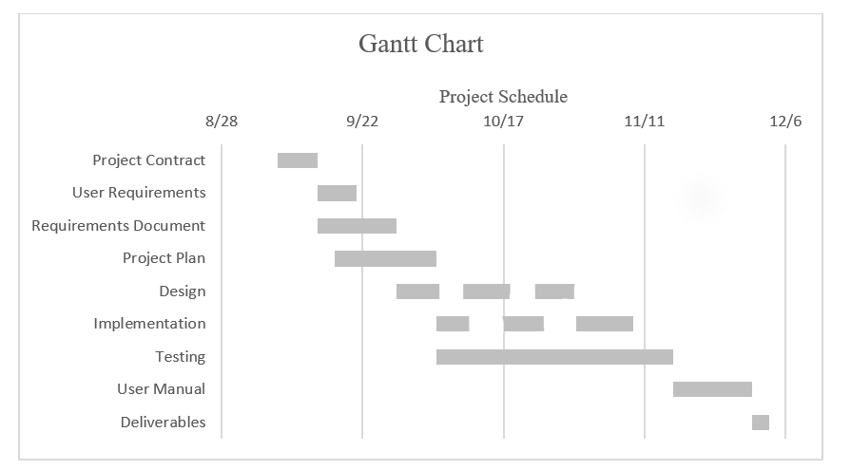

Figure 3. Gantt chart depicting each task as a duration of time for the project.

## **5.3 Task Network Diagram**

The task network diagram is a visual representation of which tasks must be completed before another task can begin. It always has a start and an end task. Our project task network diagram is pictured below in Figure 4.

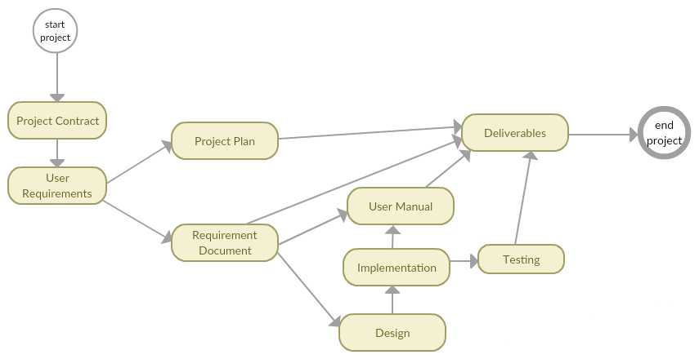

Figure 4. Task network diagram, showing the flow of task completion.

## **5.4 Object Grading Sheet**

Each team member will be responsible for updating the object grading sheet. This sheet was delivered to the team on September 24th, 2018. This document is to help ensure that quality work is achieved through team work during the development process. Each member will allocate weights and assign them to each team member for each phase of development to help objectively calculate their participation in this project. It also serves as an outline for tasks, and the resources that can be allocated to them, that need to be completed over the course of development. Since the object grading sheet is a large spreadsheet, it is attached at the end of this document.

# **6. Tracking and Control Mechanisms**

This section will discuss the methods that team TriNetra will follow to help ensure the application progresses in a controlled manner. It will address how the team is attempting to ensure the quality of the application.

## **6.1 Quality Assurance and Quality Control**

Following the requirements specifications, the team will start the design and implementation of the application. Throughout the development process, different builds will be completed during sprints. The team is currently planning to have three builds. Each Of these builds will have a design and implementation phase. Rigorous testing of the application will be completed during implementation, as well as, during the testing phase of development. During implementation, small functionality tests will be performed to ensure that component is working as intended. The testing phase will have use cases derived from the use case diagram and user context found in the requirements document. While any testing is commencing, documentation will be done to track the team’s efforts to accomplish our goals. This documentation will cover changes made during implementation, so the team can keep track of changes made in code. This is done for educational purposes so that other members may not repeat the same mistakes. This documentation will occur during the implementation and testing phases. This documentation helps ensure our goals of: efficiency, modularity, professionalism, readability, robustness, usability, and quality.

## **6.2 Change Management Control**

If a change in functionality is put forth that is not detailed in the initial requirements document, then the team will address the issue as follows. The team will access the new functionality to ensure that it is different from the defined functionalities. If it is, the team will discuss and estimate the cost in terms of time to implement and test this new functionality and whether it is feasible given the deliver deadline. If it is feasible to accomplish the new functionality by the deadline, the team will discuss where this new functionality would fit in the use case diagram to help ensure its appropriate location in the application’s subsystems. The design on the system will be referred to, followed by the implementation and testing of the new functionality within the application.

# **7. References**

[1] Cash, D. and Cortes, O. and Dodla, H. and Nalluru, J. and Baker, D. *Project Plan Mavis Rent-A-Car, Inc. Software*, Sept 2018. (https://d2l.mwsu.edu/d2l/le/content/57393/viewContent/589241/View)

[2] Iskandar, O. and Jones, M. and Moss, B. and Wuthrich, C. *Phase 2 Project Plan for Munitions Storage System*, Sept 2018. (https://d2l.mwsu.edu/d2l/le/content/57393/viewContent/589242/View)

[3] Pressman, R., *Software Engineering: A Practitioner’s Approach, 7th Ed.*, McGraw-Hill Higher Education, Boston, Mass., 2010.

[4] Stringfellow, C. *Plan Outline,* Sept 2018. (https://d2l.mwsu.edu/d2l/le/content/57393/viewContent/589269/View)